Traditional machine learning algorithms

Support vector machine (SVM): SVMs are a set of supervised learning methods used for classification, regression, and outliers detection. The python package “sklearn” provides a set of methods to access SVMs. SVC, NuSVC, and LinearSVC are classes capable of performing binary and multi-class classification on a given dataset.

Example 1:
# This is a single line comment.
# Text followed by ‘#’ in a line is comment
# A multiline comment starts with ''' and ends with '''
'''
This is a multi line comment.
This line is also a comment
'''

#import svm (support vector machine) from sklearn package
from sklearn import svm

#a simple dataset
X = [[0, 1],[1, 2],[2, 1],[2, 3],[1, 3],[2, 2]]

#labels of the dataset X
y = ['a', 'a', 'b', 'b', 'a', 'b']

#create a SVM classifier (i.e., a model) using svm.SVC()
clf = svm.SVC()

#train the model
clf.fit(X, y)

#predict the label of (3, 1)
result1 = clf.predict([[3, 1]])

#print the predicted label of (3, 1)
print(result1)

#predict the label of (0, 2)
result2 = clf.predict([[0, 2]])

#print the predicted label of (0, 2)
print(result2)
#Text in red font is the output of the program code

['b']
['a']

Example 2:
from sklearn import svm

#import dataset
from sklearn.datasets import load_iris

#iris dataset contains 150 samples, each has 4 features
X, y = load_iris(return_X_y = True)

'''
Parameter ‘return_X_y = True’ is required in load_iris()function to get the sample and label data in seperate variables.
'''

#print the size of sample
print("The size of the sample:", X.shape)

#print first 5 samples
print("First 5 samples:\n", X[0:5])
print("First 5 labels:\n", y[0:5])

#create model
clf = svm.SVC()

#train the model
clf.fit(X, y)

#predict the labels for 45th to 55th samples
result = clf.predict(X[45:55])

#print the predicted lables
print("Predicted labels\n",result)

#print the actual labels of 45th to 55th samples
print("Actual labels\n",y[45:55])

The size of the sample: (150, 4)
First 5 samples:
[[5.1 3.5 1.4 0.2]
[4.9 3. 1.4 0.2]
[4.7 3.2 1.3 0.2]
[4.6 3.1 1.5 0.2]
[5. 3.6 1.4 0.2]]
First 5 labels:
[0 0 0 0 0]
Predicted labels
[0 0 0 0 0 1 1 1 1 1]
Actual labels
[0 0 0 0 0 1 1 1 1 1]

Example 3: SVM supports various kernels as follows.

#linear kernel
linear_svc = svm.SVC(kernel=’linear’)
'''
kernel = {’linear’, ’poly’, ’rbf’, ’sigmoid’, ’precomputed’}, default=’rbf’
'''
#Radial Basis Function (RBF) kernel
rbf_svc = svm.SVC(kernel=’rbf’)

#polynoimial kernel
poly_svc = svm.SVC(kernel=’poly’, degree =3)
# degree =3 represent the third-degree polynomial

# user defined kernel
import numpy as np

#define a kernal
def my_kernel(X, Y):
return np.dot (X, Y.T)

#using the user defined kernel
clf = svm.SVC(kernel= my_kernel)

Decision Tree: It is a supervised learning method. A decision tree creates a simple model which predicts the value of a target variable by learning simple decision rules derived from the data features
Example 1: Simple data set
from sklearn import tree

#a simple dataset
X = [[0, 1],[1, 2],[2, 1],[2, 3],[1, 3],[2, 2]]

# labels of the dataset X
y = ['a', 'a', 'b', 'b', 'a', 'b']

#create a model
clf = tree.DecisionTreeClassifier()

#train the model
clf = clf.fit(X, y)

#predice the label
result = clf.predict([[3, 1]])

#print the predicted label
print(result)

#print the constructed decision tree
tree.plot_tree(clf)

['b']

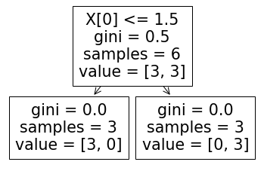

Example 2: Decision tree under a slightly complex dataset.
from sklearn.datasets import load_iris
from sklearn import tree

#create model
clf = tree.DecisionTreeClassifier()

#load dataset
X, y = load_iris(return_X_y=True)

#train the model
clf = clf.fit(X, y)

#predict the label of first sample
print(clf.predict([X[0]]))

#print decision tree
tree.plot_tree(clf)

[0]
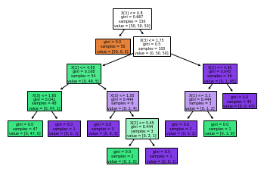

Example 3: You can also load the iris dataset like

from sklearn.datasets import load_iris
from sklearn import tree

#loading dataset without ‘return_X_y=True’ parameter
myData = load_iris()

#myData contains both the sample and labels
#print first 5-samples and 5-labels
print("First 5-samples\n",myData.data[:5])
print("First 5-labels\n", myData.target[:5])

#ctreate a model
clf = tree.DecisionTreeClassifier()

#train the model
clf = clf.fit(myData.data, myData.target)

#predict the label of first sample
result = clf.predict([myData.data[0]])
print("predicted label\n", result)

First 5-samples
[[5.1 3.5 1.4 0.2]
[4.9 3. 1.4 0.2]
[4.7 3.2 1.3 0.2]
[4.6 3.1 1.5 0.2]
[5. 3.6 1.4 0.2]]
First 5-labels
[0 0 0 0 0]
predicted label
[0]

Random Forest: Random Forest is an estimator that fits several decision tree classifiers on various sub-samples of a given dataset and improves the prediction accuracy by averaging the output of all the employed decision tree classifiers.
Example:
from sklearn.ensemble import RandomForestClassifier
from sklearn.datasets import load_iris

#load dataset
X, y = load_iris(return_X_y=True)

'''Create a RndomForestClassifier with 20 trees, each having max depth of 2. The depth of the tree reflects the complexity.
'''
clf = RandomForestClassifier(n_estimators=20, max_depth=2)
#train the model
clf.fit(X, y)

#predict the label for kth sample
k = 10
result = clf.predict([X[k]])

#print the label
print(result)

[0]

K-Means clustering: It is an unsupervised learning method, which clusters data by separating samples in n groups of equal variances.
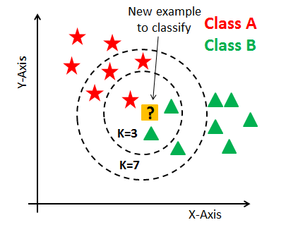
Example 1:
from sklearn.cluster import KMeans
import numpy as np

#a sample dataset
X = np.array([[1, 2], [1, 4], [1, 0],
[10, 2], [10, 4], [10, 0]])

#create a model for 2 clusters
kmeans = KMeans(n_clusters=2)

#train the model
kmeans.fit(X)

#print labels
print("Labels:\n",kmeans.labels_)

#predict the cluster
results = kmeans.predict([[0, 5], [12, 3]])

#print the predicted clusters
print("Predicted clusters:\n", results)

#print the cluster centers
print("Cluster centers:\n", kmeans.cluster_centers_)

Labels:
[1 1 1 0 0 0]
Predicted clusters:
[1 0]
Cluster centers:
[[10. 2.]
[1. 2.]]

k-nearest neighbors(k-NN): It is a neighbors-based classification, which attempts to construct a general model by simply storing the instances of the training data. The cluster of a test data is determined by a simple majority vote of the k nearest neighbors of each point.

Example 1: Number of neighbors to use (n_neighbors = 3)
#sample dataset
X = [[0], [1], [2], [3]]

#label of dataset X(only two labels)
y = [0, 0, 1, 1]

from sklearn.neighbors import KNeighborsClassifier

#create K-NN model with 3 nearest neighbors
neigh = KNeighborsClassifier(n_neighbors=3)

#train the model
neigh.fit(X, y)

#predict the label
result = neigh.predict([[2.9]])

#print the prediction
print(neigh.predict([[2.9]]))

'''
The model object (i.e., neigh) also contains the “predict_probability()” function which reflect the probability of the predicted label corresponding to particular category.
'''
#get the label prediction probability
prob = neigh.predict_proba([[2.9]])

#print label prediction probability
print(prob)

[1]
[[0.33333333 0.66666667]]

With n_neighbors = 4, the output of the above program code become

[0]
[[0.5 0.5]]

Example 2:
#sample dataset
X = [[0,0], [1,0], [2,1], [3,2], [0,4], [5,1], [1,6]]

#label of dataset X
y = [0, 1, 2, 4, 4, 3, 2]

from sklearn.neighbors import KNeighborsClassifier

#create K-NN model with 5 nearest neighbors
neigh = KNeighborsClassifier(n_neighbors=5)

#train the model
neigh.fit(X, y)

#predict the label
result = neigh.predict([[1,2]])

#print the prediction
print(result)

#label prediction probability
prob = neigh.predict_proba([[1,2]]))

#print label prediction probability
print(prob)

[4]
[[0.2 0.2 0.2 0. 0.4]]

